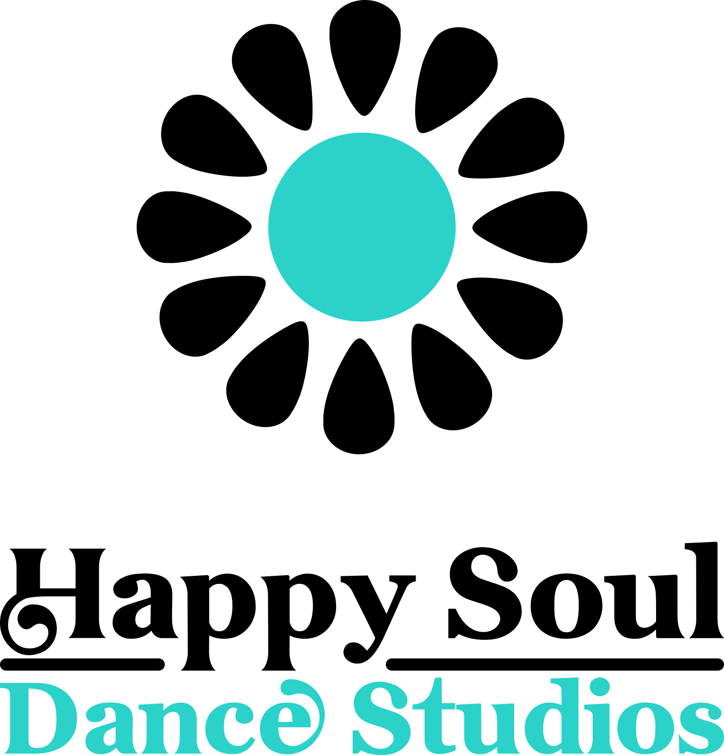
Rental Agreement
Happy Soul Dance Studios
3089 Oxford Street, Halifax, NS B3L 3W6 • 902-802-0932 • happysouldancestudios@gmail.com

Happy Soul Dance Studios and Enter Full Name agree to the following rental arrangements. Please complete form below:
 | Monday | Tuesday | Wednesday | Thursday | Friday | Saturday | Sunday | Totals
Studio A | Click or tap here to enter text. | Click or tap here to enter text. | Click or tap here to enter text. | Click or tap here to enter text. | Click or tap here to enter text. | Click or tap here to enter text. | Click or tap here to enter text. | Click or tap here to enter text.
Studio B | Click or tap here to enter text. | Click or tap here to enter text. | Click or tap here to enter text. | Click or tap here to enter text. | Click or tap here to enter text. | Click or tap here to enter text. | Click or tap here to enter text. | Click or tap here to enter text.
Total hours | Click or tap here to enter text. | Click or tap here to enter text. | Click or tap here to enter text. | Click or tap here to enter text. | Click or tap here to enter text. | Click or tap here to enter text. | Click or tap here to enter text. | Click or tap here to enter text.
Rate/s | Click or tap here to enter text. | Click or tap here to enter text. | Click or tap here to enter text. | Click or tap here to enter text. | Click or tap here to enter text. | Click or tap here to enter text. | Click or tap here to enter text. | Click or tap here to enter text.
Totals day | Click or tap here to enter text. | Click or tap here to enter text. | Click or tap here to enter text. | Click or tap here to enter text. | Click or tap here to enter text. | Click or tap here to enter text. | Click or tap here to enter text. | Click or tap here to enter text.
Date range | Click or tap here to enter text. | Click or tap here to enter text. | Click or tap here to enter text. | Click or tap here to enter text. | Click or tap here to enter text. | Click or tap here to enter text. | Click or tap here to enter text. | Click or tap here to enter text.
# of weeks | Click or tap here to enter text. | Click or tap here to enter text. | Click or tap here to enter text. | Click or tap here to enter text. | Click or tap here to enter text. | Click or tap here to enter text. | Click or tap here to enter text. | Click or tap here to enter text.
Total hours | Click or tap here to enter text. | Click or tap here to enter text. | Click or tap here to enter text. | Click or tap here to enter text. | Click or tap here to enter text. | Click or tap here to enter text. | Click or tap here to enter text.
The studio will be rented Enter Total Hours X $ Enter Hourly Rate + $ Other Fees= $Enter total
Payment method Cheque Amount Paid: $ Enter Amount
Receipt: Choose Yes/No
Phone: Enter Phone Number Email: Enter e-mail address

Rentals: Happy Soul Dance Studios is intended for dance activities such as dance classes, workshops, and rehearsals. It is also available for meetings, community gatherings, events and other artistic based work. The studio can be rented in blocks of time: one-hour minimum, ½ hour increments or by half day and full day. Book space via email, phone or in person.

Rental time: Please be conscious that the rental time agreed should include any set-up or teardown needed and must include the time needed to follow the Covid-19 cleaning protocols (approximately 10 minutes).

Equipment: Studios are equipped with mirrors, sprung dance floors, and sound systems. There is wifi, kitchenette, tables, chairs and a projector available, either free of charge or at a small fee. Currently, there is limited storage. Storage requests will be considered on a case-by-case basis.

Payment: New renters or occasional renters will pay at or before the time of each rental period. New Renters MUST pay for all studio space at or before the time it is used.

Regular Renters (Members) will be invoiced for their use of space the last day of every month. They will have 2 weeks to pay the balance. All cheques must be made to Happy Soul Dance Studios or by email transfer to happysouldancestudios@gmail.com (preferred). Cash is accepted if preferred by client. Renters will receive receipts if requested. A late fee of $20 per month will be charged for accounts that are past due.

Rental Rates:
Type | Price Studio A | Price Studio B | Notes
Regular rental rate | $30.00/hour | $25.00/hour | Studio A is 670 sq ft, Studio is B 480 sq ft
Members rental rate | $25.00/hour | $20.00/hour | Members = min 1 hour/week
Regular half day rate | $100.00 | $75.00 | Max 5 hours rental
Members half day rate | $80.00 | $60.00 | Max 5 hours rental
Regular full day rate | $160.00 | $140.00 | Max 8 hours rental
Members full day rate | $120.00 | $100.00 | Max 8 hours rental
Professional dancers discount | $18.00/hour | $15.00/hour | Daytime/late evening only
Storage locker rental | $15.00/month | $15.00/month | Individual consideration during Covid
Extra charges | $5.00 | $5.00 | Tables/chairs/projector
Special event set-up | TBD | TBD | Price will depend on the event

Cancelation policy: In the event that the renter cancels his/her rental for a specific date, Happy Soul Dance Studios needs to be notified 48 hours before the scheduled rental. If less time is given the rental fee must be paid in full. Exceptions will be made in case of extreme weather, where no fee will be charged.
Covid-19 Considerations:

Cancellation: In the event the studio must close as result of a provincial state of emergency in response to Covid-19, all classes will be cancelled. Reimbursement for pre-paid rental fees may be considered but will be influenced by the nature and duration of closure at the time.

Guidelines and Safety Plans: All renters and their students/guest must follow the Happy Soul Dance Studios Covid-19 Renters Guidelines and use the Happy Soul Dance Studios Safety Plan as a guideline for class protocols. Renters and instructors are responsible for communicating either these protocols to their respective students/guests. Renters and instructors are solely responsible for enforcing these (and other preferred) protocols for their classes.

Cleaning: Happy Soul Dance Studios will provide cleaning supplies, hand sanitizer and masks ($1.00). Renters are responsible to wipe down high-touch surface areas at the end of each class. Please refer to Covid-19 Renters Guidelines.

Shoes: Street shoes are not allowed in the dance studio and should be left in the hallway.

Storage: Storage is limited at this time. All storage requests will be reviewed on a case-by-case basis and storage fees may apply.

Keys: If renters have access to the keys to the space, renters agree not to share or make copies of the keys. When the contract ends, renters are required to return the key either in person or by mail to:
Happy Soul Dance Studios
3089 Oxford Street
Halifax, NS B3L 3W6

Emergencies: For any urgent issues, please call Lisa DeWolfe at: 902-802-0932. For urgent medical emergencies, call 911.

Damage: Each renter assumes full responsibility for any damage caused to any part of the entryway, studios, bathroom, sound systems, floors, windows, mirrors, walls, etc. sustained during the renter’s rental time. Each renter agrees to pay in full for repair or replacement of items or structure damaged by the renters, students, or guests invited to Happy Soul Dance Studios by the renter. Full payment for damage will be made within ONE MONTH of the damage.

Housekeeping: Each renter assumes responsibility for returning the studio to a good state before they leave. All windows must be closed. All lights must be turned off. Trash and litter must be removed to a garbage can. Please sweep if necessary, and leave the studio in good condition for the next renter. Non-compliance could result in fees and/or termination of this rental contract.

Parking: Street parking is available in the neighborhood. No parking is available at the building at any time.

Future Policy Changes: Happy Soul Dance Studios reserves the right to change the above rental policies and reserves the right to cancel this agreement at any time with reasonable time to inform their members.

I, Enter Full Name , am claiming responsibility for the payment of rent to Happy Soul Dance Studios for the use of studio space. I am over 18 years of age and I hereby release Happy Soul Dance Studios from any and all claims or liability due to personal injury or loss of property which I or my students may sustain at Happy Soul Dance Studios. I am responsible for damages to the facility that may occur during my session.

All of the above are hereby agreed: |  | Date: | Pick a date
Renter Print: | Enter Full Name | Happy Soul Print | Enter Full Name
Renter Signature: | By typing your name here, you are agreeing to the terms above | Happy Soul Signature | By typing your name here, you are agreeing to the terms above

